1. CREATE DATABASE
MongoDB Query:
use School
Explanation: Creates or switches to the School database.
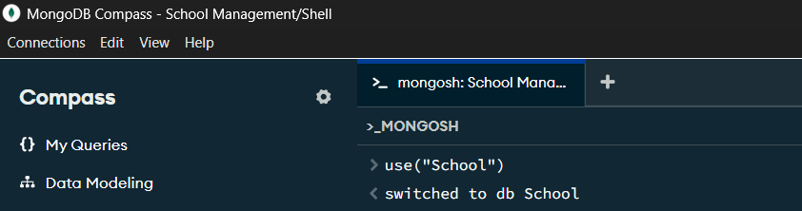

2. CREATE COLLECTION
MongoDB Query:
db. createCollection("Student")
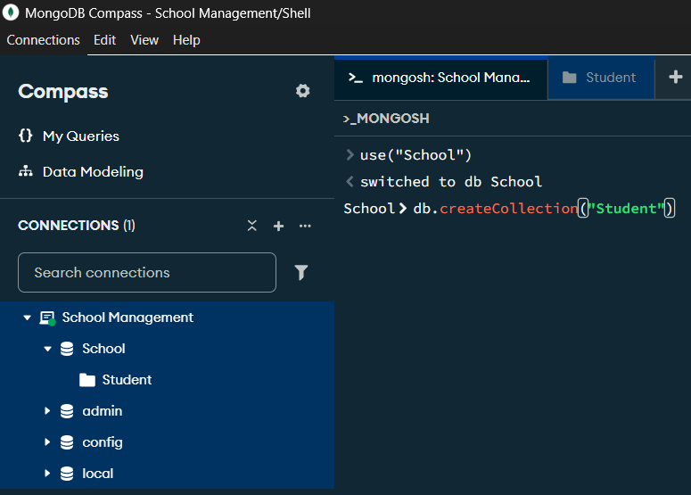
Explanation: Creates a collection named Student.

3. INSERT 50 STUDENTS
MongoDB Query:
db.Student.insertMany([
{rollno:1, name:"Aarav Sharma", age:19, marks:85, city:"Lucknow"},
{rollno:2, name:"Riya Verma", age:20, marks:91, city:"Delhi"},
{rollno:3, name:"Aditya Singh", age:18, marks:76, city:"Kanpur"},
{rollno:4, name:"Ananya Gupta", age:19, marks:88, city:"Jaipur"},
{rollno:5, name:"Rohan Patel", age:21, marks:72, city:"Ahmedabad"},
{rollno:6, name:"Sneha Mishra", age:20, marks:95, city:"Lucknow"},
{rollno:7, name:"Arjun Kumar", age:19, marks:81, city:"Patna"},
{rollno:8, name:"Priya Sharma", age:18, marks:89, city:"Delhi"},
{rollno:9, name:"Karan Mehta", age:22, marks:68, city:"Mumbai"},
{rollno:10, name:"Neha Yadav", age:20, marks:84, city:"Kanpur"},
{rollno:11, name:"Rahul Singh", age:21, marks:79, city:"Agra"},
{rollno:12, name:"Ishita Jain", age:19, marks:93, city:"Jaipur"},
{rollno:13, name:"Vivek Tiwari", age:20, marks:74, city:"Varanasi"},
{rollno:14, name:"Pooja Verma", age:18, marks:87, city:"Prayagraj"},
{rollno:15, name:"Manish Gupta", age:22, marks:69, city:"Lucknow"},
{rollno:16, name:"Kavya Singh", age:19, marks:96, city:"Bhopal"},
{rollno:17, name:"Siddharth Rao", age:21, marks:82, city:"Hyderabad"},
{rollno:18, name:"Simran Kaur", age:20, marks:90, city:"Chandigarh"},
{rollno:19, name:"Akash Sharma", age:18, marks:77, city:"Delhi"},
{rollno:20, name:"Muskan Khan", age:19, marks:86, city:"Bhopal"},
{rollno:21, name:"Dev Patel", age:20, marks:73, city:"Surat"},
{rollno:22, name:"Nisha Agarwal", age:21, marks:94, city:"Kolkata"},
{rollno:23, name:"Yash Thakur", age:19, marks:80, city:"Indore"},
{rollno:24, name:"Aditi Joshi", age:18, marks:92, city:"Pune"},
{rollno:25, name:"Mohit Kumar", age:22, marks:71, city:"Patna"},
{rollno:26, name:"Shreya Das", age:20, marks:89, city:"Kolkata"},
{rollno:27, name:"Harsh Vardhan", age:19, marks:83, city:"Noida"},
{rollno:28, name:"Tanvi Sharma", age:21, marks:97, city:"Delhi"},
{rollno:29, name:"Nikhil Verma", age:20, marks:75, city:"Ghaziabad"},
{rollno:30, name:"Sakshi Gupta", age:18, marks:88, city:"Lucknow"},
{rollno:31, name:"Abhishek Singh", age:21, marks:70, city:"Varanasi"},
{rollno:32, name:"Pallavi Mishra", age:19, marks:91, city:"Kanpur"},
{rollno:33, name:"Ayush Srivastava", age:20, marks:84, city:"Lucknow"},
{rollno:34, name:"Divya Kapoor", age:22, marks:78, city:"Mumbai"},
{rollno:35, name:"Saurabh Jain", age:19, marks:86, city:"Indore"},
{rollno:36, name:"Mehak Sharma", age:20, marks:93, city:"Jaipur"},
{rollno:37, name:"Varun Gupta", age:18, marks:67, city:"Agra"},
{rollno:38, name:"Komal Yadav", age:21, marks:81, city:"Gurugram"},
{rollno:39, name:"Rishabh Pandey", age:19, marks:90, city:"Prayagraj"},
{rollno:40, name:"Isha Malhotra", age:20, marks:85, city:"Chandigarh"},
{rollno:41, name:"Ankit Raj", age:22, marks:74, city:"Patna"},
{rollno:42, name:"Shivani Singh", age:19, marks:96, city:"Ranchi"},
{rollno:43, name:"Deepak Kumar", age:21, marks:79, city:"Noida"},
{rollno:44, name:"Mansi Gupta", age:18, marks:87, city:"Delhi"},
{rollno:45, name:"Raj Verma", age:20, marks:82, city:"Kanpur"},
{rollno:46, name:"Nandini Sharma", age:19, marks:95, city:"Pune"},
{rollno:47, name:"Aman Mishra", age:22, marks:69, city:"Varanasi"},
{rollno:48, name:"Sonia Patel", age:20, marks:89, city:"Ahmedabad"},
{rollno:49, name:"Tarun Singh", age:18, marks:77, city:"Agra"},
{rollno:50, name:"Shalini Verma", age:21, marks:92, city:"Lucknow"}
])
Explanation: Inserts multiple student documents into the collection.
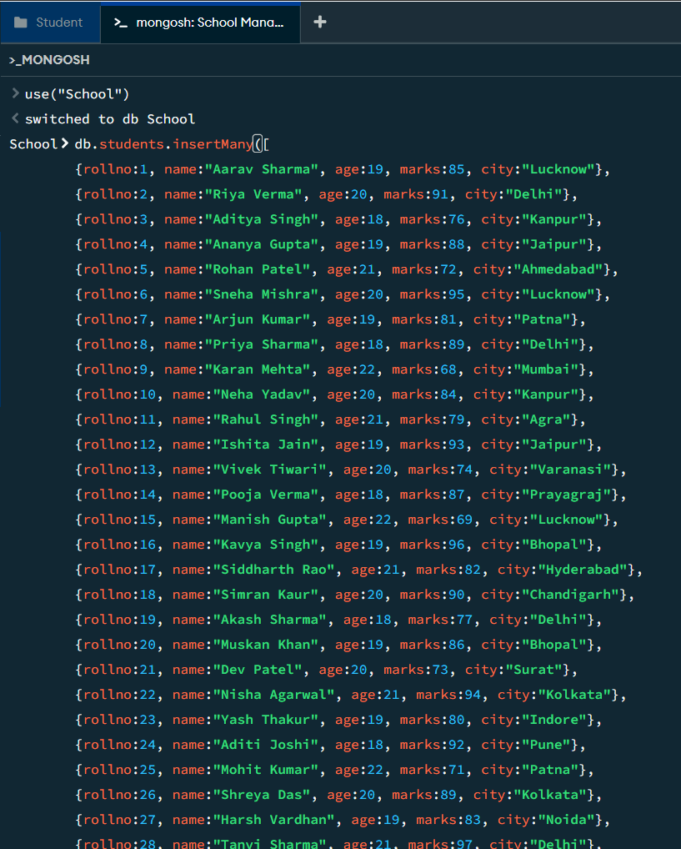

4. DISPLAY ALL STUDENTS
MongoDB Query:
db.Student.find()
Explanation: Retrieves documents from the Student collection.
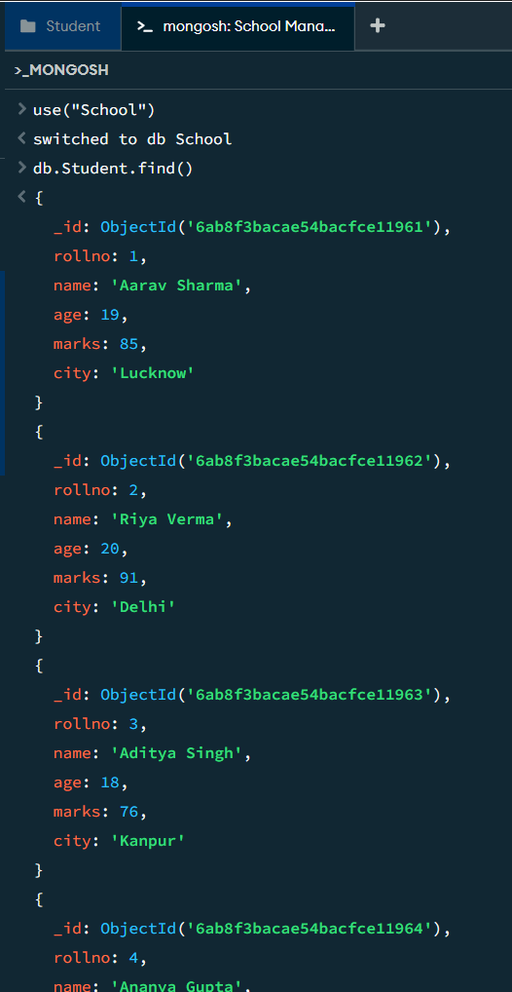

5. EQUAL TO — $eq
MongoDB Query:
db.Student.find({marks: {$eq: 88}})
Explanation: Finds students whose marks are exactly 88.
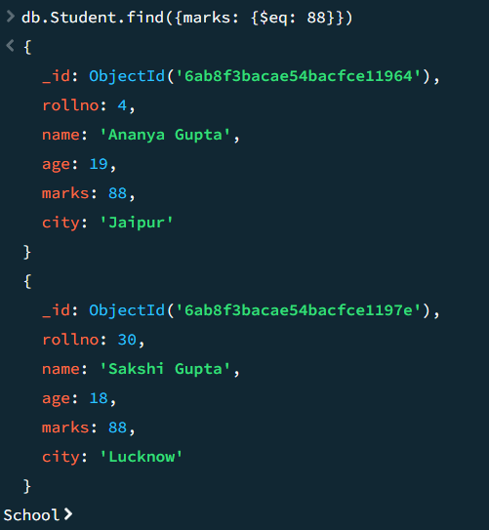
6. GREATER THAN — $gt
MongoDB Query:
db.Student.find({marks: {$gt: 85}})
Explanation: Finds students whose marks are greater than 85.
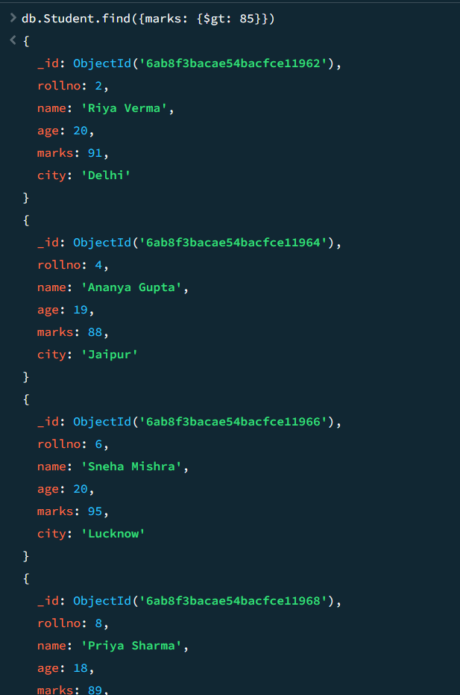
7. LESS THAN — $lt
MongoDB Query:
db.Student.find({marks: {$lt: 70}})
Explanation: Finds students whose marks are less than 70.
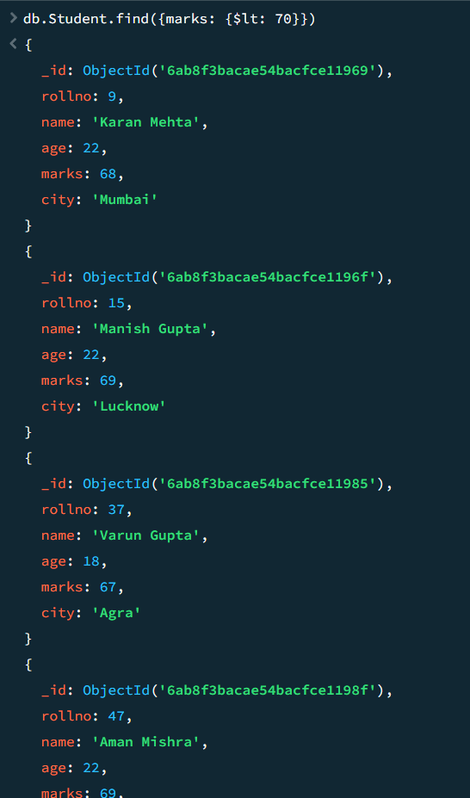
8. GREATER THAN OR EQUAL TO — $gte
MongoDB Query:
db.Student.find({marks: {$gte: 90}})
Explanation: Finds students whose marks are 90 or above.

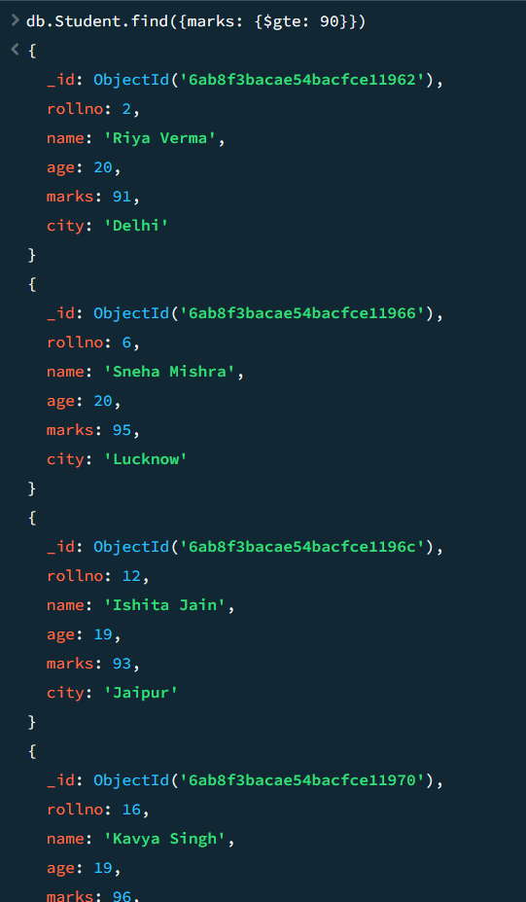

9. LESS THAN OR EQUAL TO — $lte
MongoDB Query:
db.Student.find({marks: {$lte: 70}})
Explanation: Finds students whose marks are 70 or below.
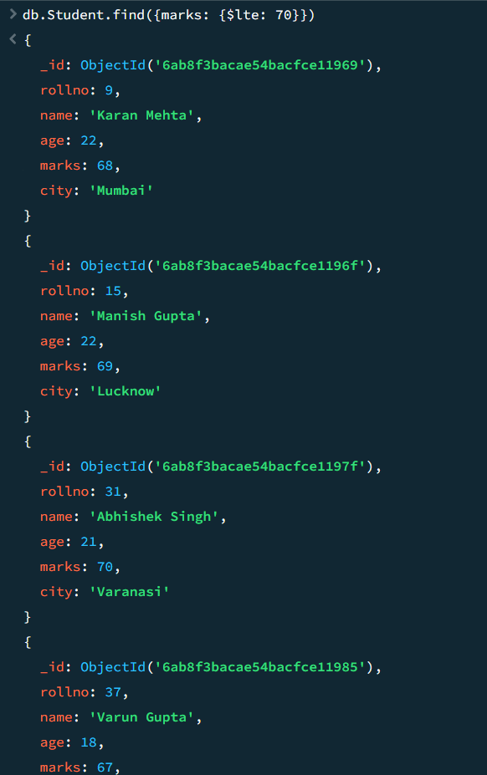

10. UPDATE OPERATION
MongoDB Query:
db.Student.updateOne(
{rollno:5},
{$set:{marks:82}}
)
Explanation: Updates the marks to 82 of the student with roll number 5.
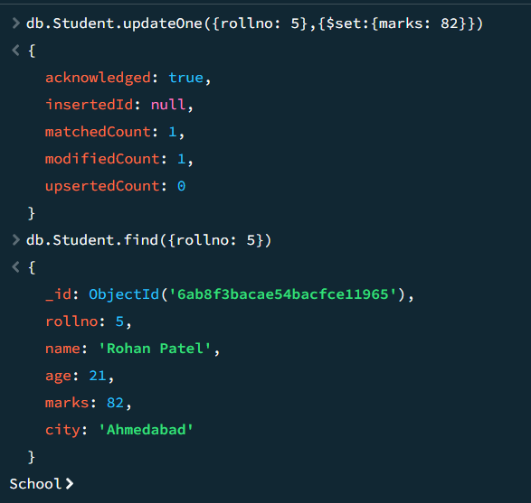

11. DELETE ONE OPERATION
MongoDB Query:
db.Student.deleteOne({rollno:10})
Explanation: Deletes one document matching roll number 10.

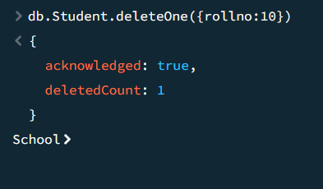

12. DELETE MANY OPERATION
MongoDB Query:
db.Student.deleteMany({
marks: {$lt:70}
})
Explanation: Deletes all students having marks below 70.
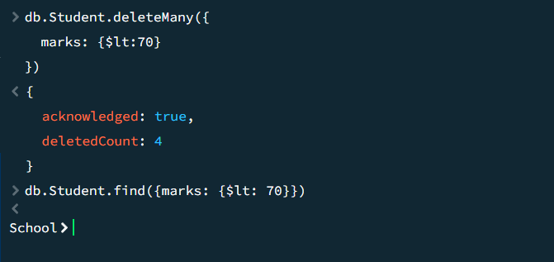

13. AND OPERATION — $and
MongoDB Query:
db.Student.find({
$and:[
{marks:{$gt:80}},
{age:19}
]
})
Explanation: Finds students satisfying both conditions.
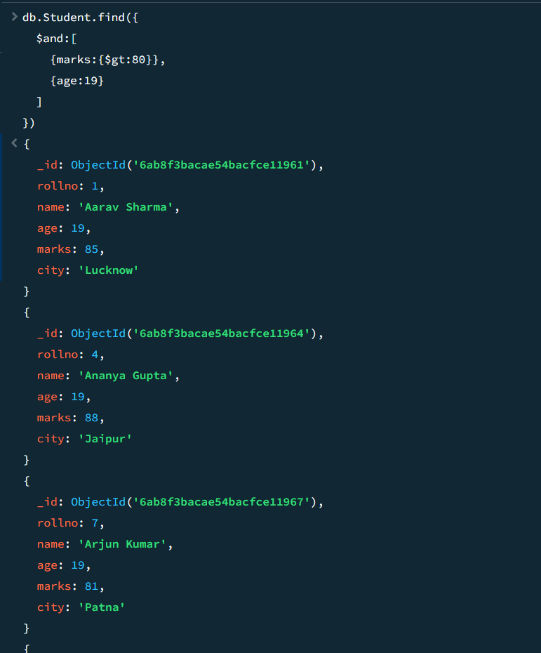

14. OR OPERATION — $or
MongoDB Query:
db.Student.find({
$or:[
{city:"Lucknow"},
{city:"Kanpur"}
]
})
Explanation: Finds students from Lucknow or Kanpur.

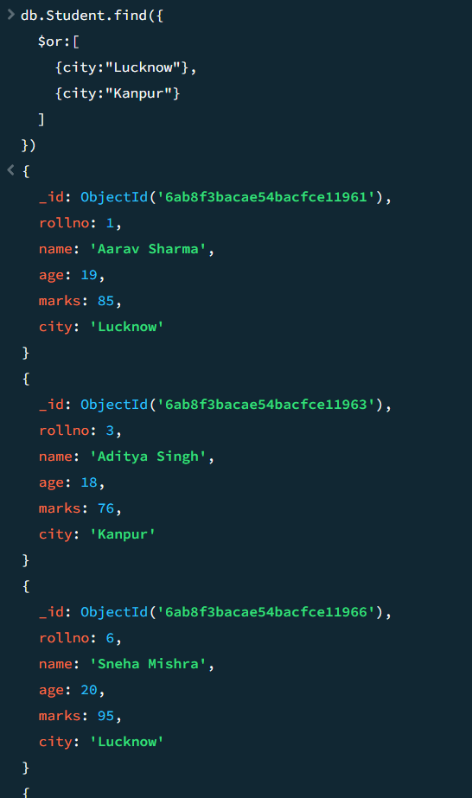
15. SORT OPERATION
A. MongoDB Query:
db.Student.find().sort({marks : 1})
Explanation: Sorts students by marks from lowest to highest. Use 1 for ascending order.
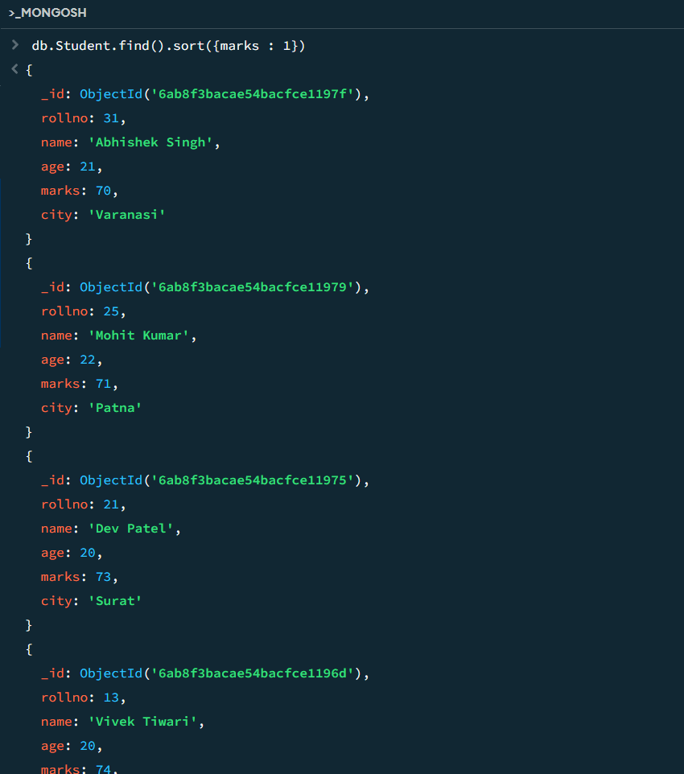

B. MongoDB Query:
db.Student.find().sort({marks: -1})
Explanation: Sorts students by marks from highest to lowest. Use -1 for descending order.
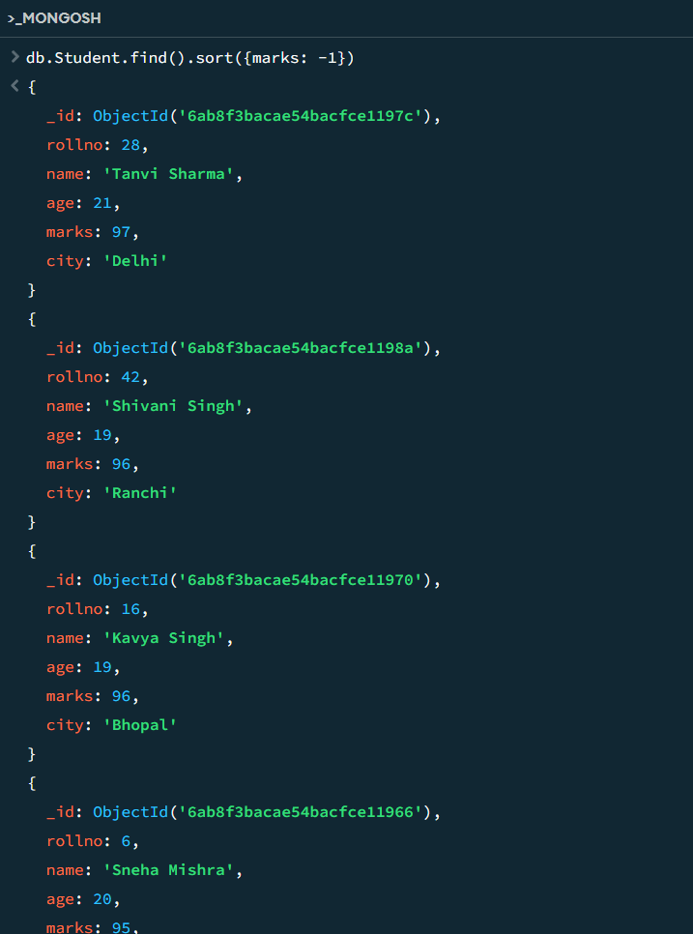
16. LIMIT OPERATION
MongoDB Query:
db.Student.find().limit(5)
Explanation: Displays only the first five documents.
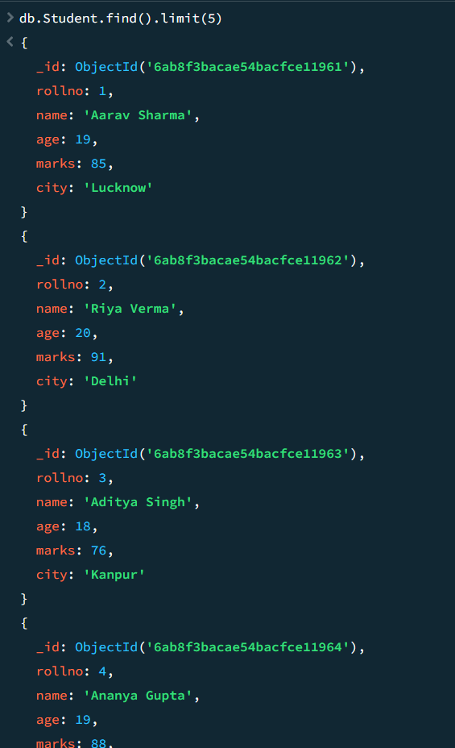

17. SEARCH BY CITY
MongoDB Query:
db.Student.find({city:"Lucknow"})
Explanation: Finds all students whose city is Lucknow.

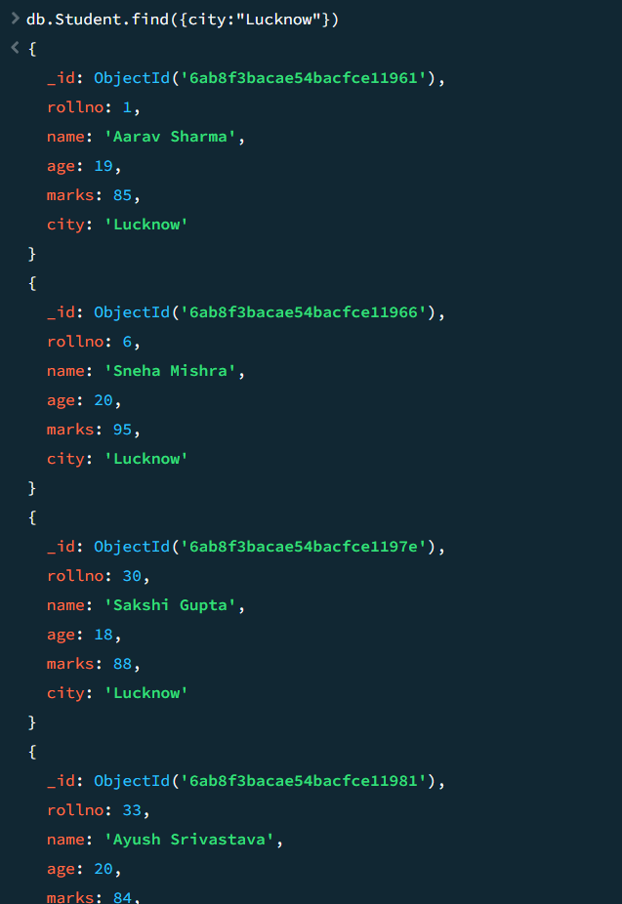
18. COUNT DOCUMENTS
MongoDB Query:
db.Student.countDocuments()
Explanation: Counts documents currently present in the collection (performing after the delete function).


